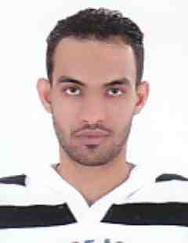

**Sayed Mohamed Naser Mohamed**

* **Driver in green Space company.**
* **Driver in Terna company.**

**WORK EXPERIENCE :**

**SKILS:**

* **Ability to work in a team.**
* **Computer Skills.**
* **Work under pressure.**

**Language:**

* **ARABIC**
* **English**

**CPR No :940701480**

**Nationality :Bahraini**

**Date of Birth : 08/07/1994**

**Address : House 1560, Road 1424,Hamad Town 1214**

**Contact No : 66952229**

**Email : S.mohammedn14@gmail.com**

* **I have the certificate of secondary school.**

**EDUCATION :**

**PERSONAL INFORMATION :**

**CURRICULUM VITAE**